Procedure: Revogene Strep A

Procedure and revision number: SN134783 REV. 01/20

Meridian Catalog # 410400

Institution:
Address:
Department:

Prepared By: | Date Adopted | Supersedes procedure #:

Distributed To: | # of Copies | Distributed To: | # of Copies

NOTE: This procedure is provided to Meridian’s customers to assist with the development of laboratory procedures. This document was derived from, and was current with, the instructions for use (IFU) that accompanies the product at the time it was created. The user is instructed to consult the IFU packaged with the product to ensure currency of the procedure prior to adapting the document to routine laboratory use and periodically thereafter to ensure future IFU modifications, which might affect this procedure, are identified. Any modifications to this document are the sole responsibility of the person making the modifications.

PRINCIPLE:
The Revogene® Strep A assay, performed on the Revogene instrument, is an automated, qualitative in vitro diagnostic test that utilizes real-time polymerase chain reaction (PCR) for the direct detection of Streptococcus pyogenes (Group A β- hemolytic Streptococcus) nucleic acids from throat swab specimens obtained from patients with signs and symptoms of pharyngitis. The Revogene Strep A assay is intended for use as an aid in the diagnosis of Group A Streptococcus infection.

The Revogene automates sample homogenization and dilution, cell lysis, DNA amplification and detection of the amplified PCR products. User intervention is only required to discharge the patient specimen into the Sample Buffer Tube (SBT), transfer the sample from SBT into the PIE and insert the PIEs into the Revogene carousel.

Each PIE is a fully integrated closed device in which a sample is dispensed and processed through different microfluidic chambers and channels which allow for the sample processing (i.e. sample homogenization, sample dilution, cell lysis and DNA extraction) and subsequent real-time PCR steps (Figure 1). The liquid from a single sample is transferred by centrifugation from one chamber to the next in sequence. All reagents specific for the PCR reaction are incorporated and dried within the PCR well. A Process Control (PrC) is incorporated into each PIE to verify sample processing and amplification steps including the verification of potential inhibitor substances as well as microfluidic, instrument or reagent failure. The amplified products are detected in real-time using target-specific TaqMan® chemistry-based probes. No operator intervention is necessary once a PIE is loaded into the Revogene.

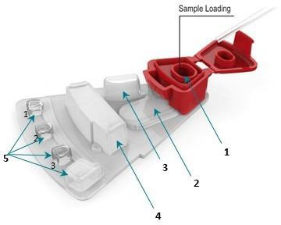
Figure 1. Top View of PIE. 1: Sample Loading Chamber, 2: Homogenization Chamber Containing PrC, 3: Overflow Chamber, 4: Dilution/Lysis Chamber, 5: Three PCR Wells (#1 to #3, on the left) and one Waste Chamber (on the right).

The Revogene can process from one (1) up to eight (8) samples simultaneously in the same run. The carousel must contain eight (8) PIEs to maintain thermodynamic balance within the run. During the run and at run completion, the results are computed by the system from measured fluorescent signals and embedded calculation algorithms. Results that are displayed on the touchscreen may be printed, transferred and stored by the user using the USB port or the connectivity option.

An Early Positive Result Outcome (E-PRO) feature provides positive result if the signal from the target DNA reaches a predetermined threshold before the full PCR cycles have been completed. With E-PRO, a positive result could be obtained in approximately 42 minutes for strongly positive samples. For negative samples, the time to result is approximately 70 minutes.

SPECIMEN:
Preferred Sample Type:
- Throat swabs in Liquid Amies or Stuart’s transport media.
- Acceptable swabs: Rayon or polyester with plastic shafts.

Undesirable Specimens:
- Collection/transport systems other than those specified above.
- Throat swabs containing gel or charcoal transport media.
- Eswabs

Collection and Storage:
- Swab the posterior pharynx, tonsils and other inflamed areas following standard clinical methods and secure the swab in its transport sheath.
- Label the transport sheath with the specimen or patient identification (ID) and send to the laboratory for testing
- Throat swab specimens should be stored between 2 C and 25 C during transport.
- Throat swab specimens can be stored at 25 C for up to 2 days, or at 2-8 C for up to 7 days.
- Inoculated SBT can be stored at 25 C for up to 3 days, or at 2-8 C for up to 7 days.

This facility’s procedure for specimen collection is: _____________________________________ ______________________________________________________________________________

This facility’s procedure for transporting specimens is: __________________________________ ______________________________________________________________________________

This facility’s procedure for rejected specimens is: _____________________________________ ______________________________________________________________________________

REAGENTS AND MATERIALS PROVIDED
Revogene Strep A kit containing sufficient reagents and materials to process 24 samples. The kit contains 24 individual pouches and each pouch contains the following materials (Figure 2):
- One (1) Disposable Transfer Tool (DTT): Plastic pipette with minimal and maximal volume marks for transferring the sample from the SBT to the PIE.
- One (1) Strep A Sample Buffer Tube (SBT): Tube containing Tris-HCl pH 8.0/EDTA Na₂ (TE 1X) buffered solution as a dilution and preservation buffer for sample.
- One (1) Strep A Microfluidic cartridge (PIE): Integrated device, composed of dried reagents allowing sample preparation and real-time PCR steps for PrC DNA, GAS DNA amplification and detection. Each PIE contains PrC, PrC- specific primers and Taqman® chemistry-based probe, GAS gene-specific primers and Taqman® chemistry-based probes, dNTPs, buffer and DNA polymerase.
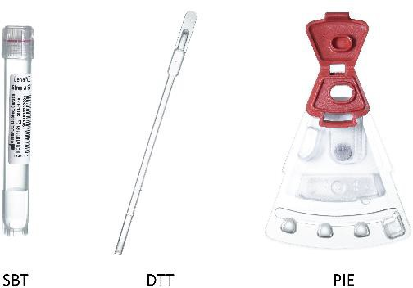
Figure 2. Revogene SBT, DTT and PIE

MATERIALS/EQUIPMENTS REQUIRED BUT NOT PROVIDED
- Revogene® (cat# 610210)
- Disposable powderless gloves
- Rayon or polyester swabs with Liquid Stuart or Liquid Amies transport media compatible with throat specimen collection (Copan cat. #139C, 138C, 140C and 141C; BD cat# 220146 and 220149).
- Vortex mixer with a maximal speed of at least 3,200 rpm
- Gauzes
- MOCK PIEs (cat# 610208; optional)
- Sample Rack (cat# 132539; optional)
PERFORMANCE CONSIDERATIONS:
- The Revogene Strep A assay can only be used on the Revogene.
- Do not use the kit if the label that seals the outer box is broken upon arrival.
- Do not use Strep A PIEs if the protective pouches are open or broken upon arrival.
- Do not interchange DTT, SBT, and PIE between kit lots.
- Each single-use DTT and Strep A PIE are used to process one (1) sample. Do not reuse DTT or PIE.
- Do not use swab with gel’s transport media.
- Always handle samples as if they are infectious and in accordance with Good Laboratory Practices such as those described in Biosafety in Microbiological and Biomedical Laboratories and in CLSI Document M29-A4.
- Wear disposable powderless gloves while handling samples and thoroughly wash hands afterwards.
- The Strep A PIE contains dried reagents. The protective pouch should not be opened until ready to perform the test.
- Dispose of unused materials, reagents and waste in accordance with country, federal, provincial, state and local regulations.
- Do not open or break apart the PIE after use to avoid contamination with amplification products and/or infectious particles.
- Do not use a PIE that has been dropped, shaken or inverted after the sample has been loaded as this may cause invalid results.
- Do not use a kit that has passed its stated expiration date.
- Do not refrigerate the loaded PIE.
- Each run must be performed with eight (8) PIEs in the Revogene carousel to maintain thermodynamic and mechanical balance within the run. Place MOCK PIEs or new assay PIEs loaded with Sample Buffer in empty positions if less than eight samples are tested.

STORAGE REQUIREMENTS:
  - Store the Revogene Strep A kit at 2-25 C.
  - The expiration date is indicated on the box kit’s label and on each pouch.
  - Do not open a pouch until ready to perform testing.
  - Use the PIE within one (1) hour after opening the pouch.

At this facility, kits are stored:_______________________________________________

CALIBRATION:
Not applicable to this assay.

QUALITY CONTROL
Quality control procedures monitor the accuracy and precision of the analytical process. Each laboratory must establish the number, type and frequency of testing control materials per applicable regulations or accrediting agencies. The procedure described below may be employed, if appropriate, based on local policies and procedures.

PROCESS CONTROL
Each Strep A PIE contains a Process Control (PrC) that verifies for sample homogenization, sample dilution, cell lysis, inhibition of DNA amplification and assay reagents failure.

EXTERNAL CONTROLS
NOTE 1: Separate DTT, SBT and PIE must be used for each External Control preparation.
  - Good laboratory practices recommend the use of control materials. User should follow the appropriate guidelines concerning the running of External Controls. It is recommended that one (1) Positive External Control and one (1) Negative External Control should be run at least on a daily basis until adequate process validation is achieved with the Revogene Strep A assay on the Revogene in each laboratory setting.
  - External Control materials are not provided by Meridian Bioscience, Inc. External Controls are not used by the Revogene software for the purpose of sample test result interpretation. External Controls are treated as if they are specimens.
  - Before reporting early positive sample results, ensure to have Valid Positive and Negative External Control results.
Positive External Controls
- A cell suspension of a Streptococcus pyogenes strain, from commercially available strain (e.g. ATCC® 12344™, prepared at 0.5 ± 0.05 McFarland diluted 1/100 in saline (e.g., BD BBLTM Prepared Saline Solution, cat# 221819) is recommended as a Positive External Control.
Negative External Control
- A cell suspension of a Streptococcus salivarius strain, from commercially available strain (e.g. ATCC® 13419TM), prepared at 0.5 ± 0.05 McFarland in saline (e.g., BD BBLTM Prepared Saline Solution, cat# 221819) is recommended for use as a Negative External Control.

1. Process and test External Control preparations according to the Instruction for Use section.
2. At step 4, remove an unused, compatible swab from its transport sheath and quickly dip it in the Positive or Negative External Control suspension (ensure to completely submerge swab’s tip in the liquid).
3. Transfer the swab in the SBT.
4. Continue with the instructions in the Instruction for Use section at step 4-C.
QC Testing Frequency and Documentation:

For this facility, External QC is run: __________________________________________________

Results of External QC and action(s) taken when control results are unacceptable are documented: ___________________________________________________________________
PROCEDURE:
SBT PREPARATION:
NOTE 1 : The content of one (1) pouch is required for each specimen to be tested.
NOTE 2 : Make sure only one (1) SBT is open at any given moment and remove only one (1) swab from its transport sheath at a time.

Step 1
Remove the appropriate number of pouches from the box.

Step 2
A- For each specimen to be tested, unseal the right side of each pouch (when facing label) and remove the SBT (Figure 3).
B- Leave the DTT in the pouch.
NOTE : Unseal the left part of the pouch only when ready to load the PIE. Start the test within on (1) hour after opening the pouch containing the PIE.
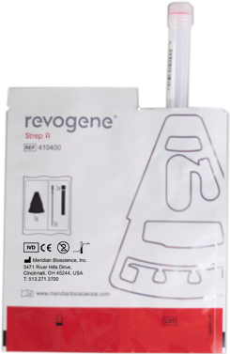
Figure 3. Remove SBT from the pouch

Step 3
A- Identify (or label) the SBT with the appropriate specimen identification without obscuring or writing over the barcode.
B- Place the SBT on the Revogene Sample Rack, if used.

Step 4
A- Unscrew the SBT cap.
B- Remove the swab from its transport sheath and transfer it in the SBT.
C- Break the exceeding part of the swab stem (Figure 4):
- Hold the stem with a gauze.
- Lift the stem a few millimeters (mm) from the bottom of the tube.
- Bend the stem against the edge of the tube to break it.
- Alternatively, use clean scissors to cut the stem. Disinfect scissors between each sample.
- Dispose of the swab sheath and stem according to your institution's standard practices.
- Close the SBT cap tightly.
D- Repeat step 4 for each sample to be tested.

NOTE : A new gauze must be used for each sample to avoid cross-contamination between samples and aerosols.
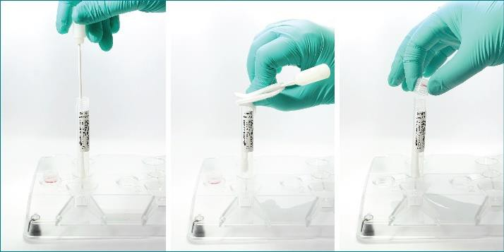
Figure 4. Break the Swab in the SBT


Once broken, the swab stem should be shorter than the rim of the SBT to adequately discharge the sample in the SBT. The SBT cap should close without hindrance from the swab stem.

PIE PREPARATION:
NOTE 1 : Process one sample at a time
NOTE 2 : Manipulate the DTT only by the bulb to avoid contamination of sample.

Step 5

A- Mix the SBT for a minimum of 15 seconds at maximal speed (> 3200 rpm) using a vortex mixer (Figure 5):
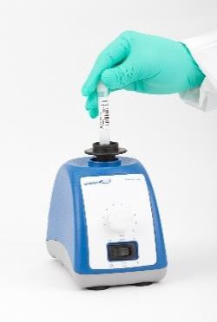

Figure 5. Vortex the SBT

Step 6

A- Unseal the left side of the pouch (when facing the label) and remove the PIE (Figure 6).
B- Place the Strep A PIE on the Sample Rack, if used, or on a flat surface.

NOTE: Hold the PIE by the dilution chamber or by its sides to avoid smearing on PCR wells.

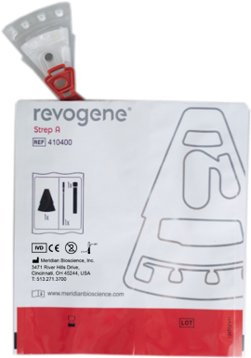
Figure 6: Remove the PIE from the Pouch

Step 7
A- Unscrew the SBT cap and remove the DTT from the pouch (Figure 7).
B- Aspirate the Sample Buffer (SB) by squeezing the entire bulb, placing the pipette tip into the sample buffer and slowly releasing the pressure on the bulb. The liquid should rise between the two marks on the DTT. (Figure 8). If the liquid level is not between the two marks, discharge completely the SB in the SBT and repeat step B.

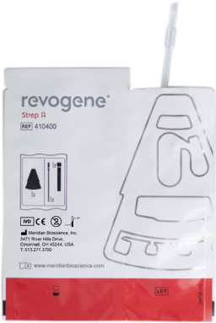

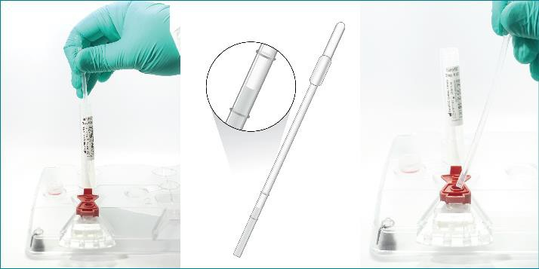
Figure 7. Remove the DTT from the pouch

Figure 8. Aspirate SB with the DTT and Load the PIE

NOTE: Do not aspirate bubbles.

C- Discharge completely the SB volume contained in the DTT into the Sample Loading chamber of the PIE by squeezing the DTT bulb (Figure 8). Make sure not to touch the outer edges or the bottom of the Sample Loading chamber with the DTT.
D- Dispose of the DTT according to your institution's standard practices. Do not reuse DTT.
E- Close the cap of the PIE tightly.
F- Close the SBT cap tightly.
G- Repeat steps 5 to 7 for any additional prepared SBT then proceed to step 8.

NOTE: Be cautious when manipulating a loaded PIE. Do not invert, shake or drop. If it happens, discard and prepare a new one starting from step 5.

Revogene Operation:
NOTE 1: Refer to the Revogene Operator’s Manual for further information regarding revogene operation.

Step 8
A- Log in by entering <Username> and <Password> and tap <Login> (Figure 9).
B-Tap <Setup Run> on the main menu (It will automatically unlock the lid if it is closed) (Figure 10)

C- Open the lid and remove the retention ring.
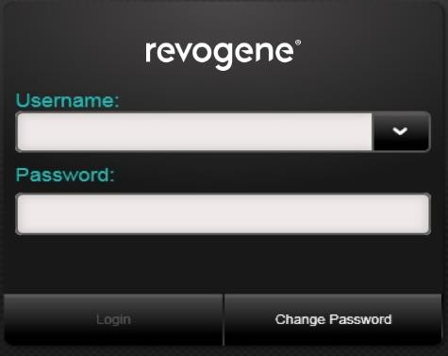

Figure 9. Login Screen

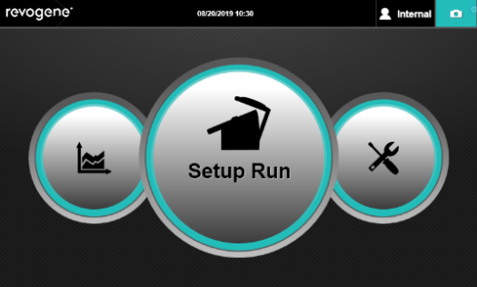
Figure 10. Main Menu Display (Hand on Setup Run Icon)

Step 9
A- Enter the Sample ID using the barcode scanner or the on- screen keyboard (Figure 11):
- To scan the SBT, hold it vertically in front of the scanner.
- To use the on-screen keyboard, tap on the pencil icon. Manually entered Sample ID will need to be confirmed by entering it a second time.

B- Scan the SBT barcode.
C- Scan the PIE barcode holding it vertically with the cap at the top (Figure 12).
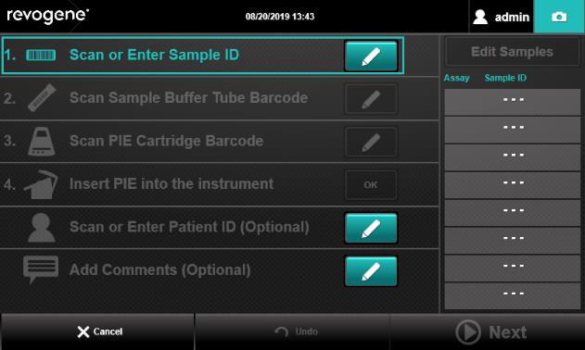
Figure 11. Setup Run Instructions Display

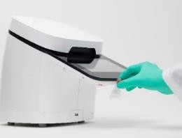
Figure 12. Scanning PIE
NOTE: Do not invert, shake or drop the loaded PIE. Should it happen, discard and prepare a new PIE starting from step 5.

D- (Optional) Tap the pencil icon of the <Patient ID> line and type the patient ID using the on-screen keyboard.
E- (Optional) Tap the pencil icon of the <Add Comments> line and type a comment using the on-screen keyboard.
F- Insert the PIE into the revogene carousel while holding it by its sides or by the dilution chamber (Figure 13).
- Any of the eight (8) positions of the carousel can be used. The software will automatically associate sample and SBT to the correct PIE.
G- Tap <ok> on the <insert PIE into the instrument> line to confirm that the PIE is inserted.
H- Repeat step 9 for all loaded PIE.
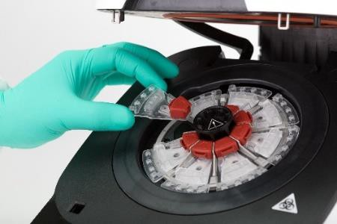
Figure 13. Inserting PIE

Step 10
A- Tap <Next>.
B- If less than eight (8) PIEs are being tested, load MOCK PIEs in the carousel remaining positions (MOCK PIEs do not need to be scanned) (Figure 14). If MOCK PIEs are not available, use new assay PIEs filled with un-inoculated SB (BLANK).
C- Tap the Confirm checkbox.
D- Scan the retention ring and place it on the carousel (Figure 15).
E- Close the instrument lid.
F- Tap <Start> to initiate the test (Figure 16).
- A timer on the screen and lights on the Revogene lid will show the progression of the test.
G- Store the inoculated SBT in appropriate conditions (refer to Storage and Stability section) for further repeat testing, if needed.
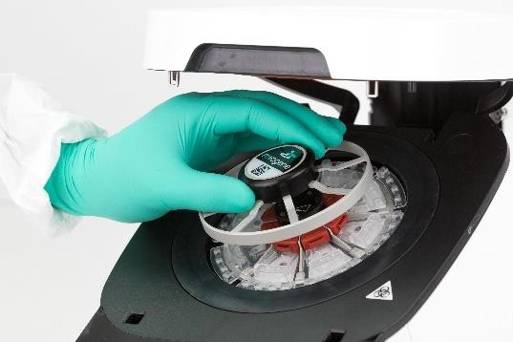
Figure 14. Adding Mock PIE
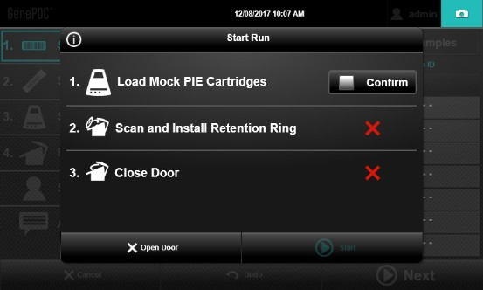

Figure 15. Placing Retention Ring

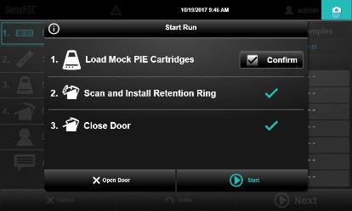
Figure 16. Confirm Run Start

Viewing and Exporting Results:

Step 11 - During the run
A- If the lights indicating run progression on the Revogene lid start to blink, this is a notification for an Early Positive Result Outcome (E-PRO). An icon will also appear on the title bar of the screen.


The E-PRO icon includes the “+” symbol and a number representing the number of Positive results available at this time (Figure 17). The number will increase if additional positive results become available.

Figure 18. E-PRO Icon
B- Enter <Username> and <Password> and tap <Login> if the user’s session has logged-out.
C- Tap the E-PRO icon.
D- Results from the current run are automatically listed on the screen (Figure 18). For each sample line, there will be either a Positive symbol or an In-Progress symbol. The In-Progress symbol, consisting of a rotating animation, is displayed until a positive result is obtained or the run is completed.
E- Tap on a positive result symbol to open the interim report.
F- (Optional) Tap <Export> and save the interim report where appropriate (e.g. USB key or connectivity option).

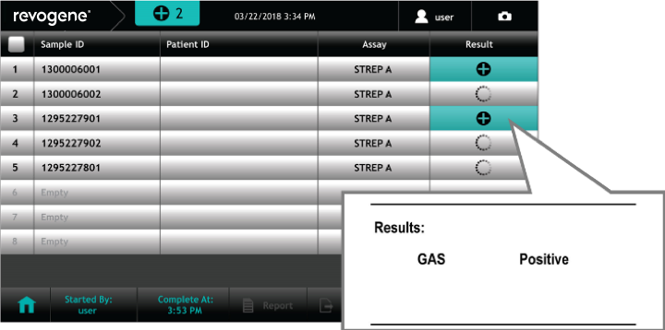
Figure 18. In progress Results Display
Once the results screen has been consulted, the E-PRO notifications will disappear. New E-PRO notifications will appear upon the detection of an additional Early Positive Result.

Any sample result displayed in the interim report is final and will remain unchanged in the final assay result report.

Step 12 - At the End of the Run
A- Once the run is completed, the lid opens automatically.
B- Enter <Username> and <Password> and tap <Login> if the user’s session has logged-out.
C- Tap Results icon (Figure 19).
D- Results from the last run are automatically listed on the screen.
E- Select samples for which results report(s) has (have) to be exported:
- All samples can be selected simultaneously by checking the box on the upper left corner of the screen.
F- Tap <Export> and save the final assay result report where appropriate (e.g. USB key or via connectivity option) (Figure 20).
G- Alternatively:
- Tap <Search> to find a specific sample and its result.

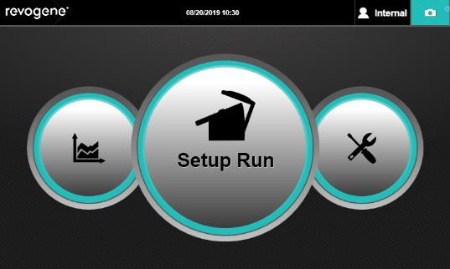
Figure 19. Main Menu Display (Hand on Results Icon)

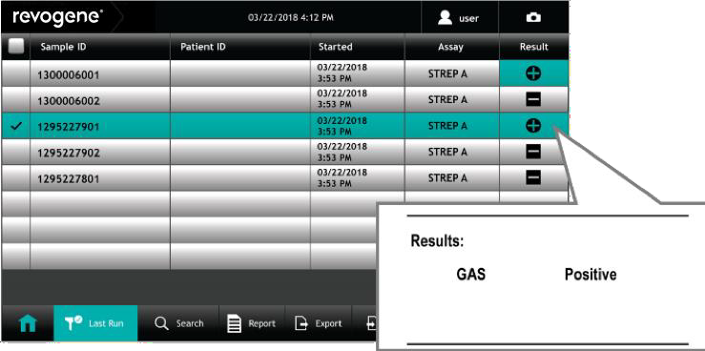

Figure 20. Final Results Display

Step 13
A- Remove the retention ring
B- Remove the PIEs from the Revogene
- Dispose of the PIEs according to your institution's standard practices.
NOTE : Do not discard MOCK PIEs as they can be reused. Clean and decontaminate MOCK PIE according to the MOCK PIE Package Insert.
REPEAT TESTING PROCEDURE :
UNRESOLVED OR INDETERMINATE RESULT FOR A SPECIMEN :
When an Unresolved (UNR) or an Indeterminate (IND) result is obtained for a specimen, a repeat test from the corresponding inoculated SBT must be performed within the specified timeframe described in the Storage and Stability section. Only one repeat testing from the SBT is allowed.

Use the corresponding inoculated SBT to load a new PIE from the same kit lot. Follow the PIE Preparation section from step 5, then follow the Revogene Operation section.

UNRESOLVED OR INDETERMINATE RESULT FOR AN EXTERNAL CONTROL:
When an Unresolved (UNR) or Indeterminate (IND) result is obtained for an External Control, the run is
invalid. A repeat test must be performed for both the Positive and Negative External controls from the
corresponding inoculated SBT within the specified timeframe described in the Storage and Stability section. Specimens included in the run must be repeated using the corresponding inoculated SBT. Only one repeat
testing from the SBT is allowed.

Use the corresponding inoculated SBT to load a new PIE from the same kit lot. Follow the PIE Preparation
section from step 5, then follow the Revogene Operation section.

FALSE NEGATIVE OR FALSE POSITIVE RESULT FOR AN EXTERNAL CONTROL:
When a False Negative or a False Positive result is obtained for an External Control, the run is invalid. Both
controls must be repeated using a new set of External Controls.
In addition, repeat testing must be performed for all samples included in the run, using the corresponding
inoculated SBT within the specified timeframe described in the Storage and Stability section with a new
set of External Controls. Only one repeat testing from the SBT is allowed.

Refer to the Quality Control section for preparation of a new set of External controls.

Using a new pouch, follow the PIE Preparation section from step 5, then follow the Revogene Operation section.

CALCULATIONS:
There are no calculations associated with this procedure.

INTERPRETATION OF RESULTS:

Sample | Symbol displayed on  user screen | Reported Target Result | Interpretation
Patient Specimen |  | Positive | GAS target DNA detected.
Patient Specimen |  | Negative | GAS target DNA not detected.
Patient Specimen |  | Unresolved | Amplification/detection failure of the Process Control as well as for the GAS target DNA. Could be caused by inhibitory specimens, microfluidic or reagent failure. Repeat testing must be performed (refer to the Repeat Testing Procedure section for further guidance).
Patient Specimen |  | Indeterminate | No reportable result due to possible revogene detection error during the assay processing, the data analysis, or if the run is interrupted by the user. Repeat testing must be performed (refer to the Repeat Testing Procedure section for further guidance).
Patient Specimen |  | In progress | Results not available yet
Positive External Control |  | Positive | Valid Positive External Control result.
Positive External Control |  | Negative | A Positive External Control that yields a negative result is indicative of a sample handling/preparation problem. The run is invalid. Review the sample handling/preparation technique.
Positive External Control |  | Unresolved | Incorrect Positive External Control result. The run is invalid. Repeat testing must be performed (refer to the Repeat Testing Procedure section for further guidance).
Positive External Control |  | Indeterminate | Incorrect Positive External Control result. The run is invalid. Repeat testing must be performed (refer to the Repeat Testing Procedure section for further guidance).
Positive External Control |  | In progress | Results not available yet
Negative External Control |  | Positive | A Negative External Control that yields a positive test result is indicative of a specimen handling and/or contamination event. The run is invalid. Review the specimen handling technique.
Negative External Control |  | Negative | Valid Negative External Control result.
Negative External Control |  | Unresolved | Incorrect Negative External Control result. The run is invalid. Repeat testing must be performed (refer to the Repeat Testing Procedure section for further guidance).
Negative External Control |  | Indeterminate | Incorrect Negative External Control result. The run is invalid. Repeat testing must be performed (refer to the Repeat Testing Procedure section for further guidance).
Negative External Control |  | In progress | Results not available yet

REPORTING OF RESULTS:

Positive Test: GAS target DNA detected.
Negative Test: GAS target DNA not detected.

This facility’s procedure for reporting patient’s results is: ________________________________ ______________________________________________________________________________

EXPECTED VALUES:
In a prospective clinical trial, a total of 767 throat swab specimens were collected at 7 geographically diverse sites across the United States and Canada from February to July 2018. Of the 604 specimens meeting all inclusion criteria without meeting any of the exclusion criteria, 154 were positive based on the Reference Method for an observed prevalence of 25.5% [154/604; 95%CI 22.2% - 29.1%]. The percentage of positive results observed with the Revogene Strep A assay in the study population was 29.0% [175/604; 95%CI 25.5% - 32.7%].

ASSAY REACTIVITY:
The analytical sensitivity (Limit of Detection or LoD) of the Revogene Strep A assay was determined using clinical throat swab specimen matrix (previously tested negative for S. pyogenes) spiked with of various concentrations of S. pyogenes bacterial suspensions. Three strains of S. pyogenes (ATCC® 12344™, ATCC® 19615™, ATCC® 700942™) were tested in 24 replicates per concentration. The LoD is defined as the lowest concentration at which 95% or more of all replicates tested positive.

In regard to the three strains tested, the LoD of the Revogene Strep A assay ranged from 333 to 1333 CFU/mL of SB (Table 3). The preliminary LoD concentrations were confirmed by testing twenty (20) replicates of each strain.

Table 3. LoD of the Revogene Strep A Assay
S. pyogenes strain  (ATCC® number) | LoD  (CFU/mL of SB)
ATCC® 12344™ | 333
ATCC® 19615™ | 1000
ATCC® 700942™ | 1333

INCLUSIVITY
Inclusivity of the Revogene Strep A assay was determined for twelve strains of S. pyogenes representing six different emm sequence types from diverse geographic origins. Nine strains were tested from a quantitated cell culture in presence of S. pyogenes-negative throat matrix at a load of 999 CFU/mL of SB, corresponding to three times the LoD value of ATCC® 12344™ strain. Nine replicates per strain were tested using three different Revogene Strep A kit lots. Eight strains were detected with 100% positivity (in 9/9 replicates) by the Revogene Strep A assay at a load of 999 CFU/mL of SB. The S. pyogenes ATCC® 49399™ strain was detected with 100% positivity at a load of 1667 CFU/mL of SB. Strains tested are described in Table 4.

Table 4. S. pyogenes Strains Tested for Inclusivity with the Revogene Strep A assay
S. pyogenes strains | Lancefield grouping | emm type
ATCC® 12384™ | A | 3
ATCC® 49399™ | A | N/A
CCUG 33409 | A | N/A
CCUG 39158 | A | N/A
CCUG 53553 | A | N/A
ATCC® 700952™ | A | 92
ATCC® 700294™ | A | 1
ATCC® 12357™ | A | 18
CCUG 65322 | A | N/A
ATCC® 19615™1 | A | 80
ATCC® 12344™1 | A | 1
ATCC® 700942™1 | A | 82
1 Strains used for the LoD determination and therefore not retested

In addition, an in silico analysis was performed on August 8th, 2018 to assess inclusivity of the primers and probe of the Revogene Strep A assay target regarding 123 S. pyogenes strains listed in the National Center for Biotechnology Information (NCBI) database. This included sequences of S. pyogenes strains of significant emm types included in candidate vaccines against Group A Streptococci. The alignment results showed no mismatch with 122 sequences. One variant presented a mismatch in the region corresponding to the S. pyogenes probe, however, this variant is considered detectable by the Revogene Strep A assay. The analysis predicted the detection of all these S. pyogenes strains.

TESTS FOR INTERFERING SUBSTANCES:

INTERFERING ORGANISMS
The potentially inhibitory effect of 30 organisms, that may be present in the normal flora of the throat, mouth and/or respiratory tract was assessed using organisms selected from the cross-reactivity study (Table 6). Each organism category (i.e. bacteria, yeast, viruses) was represented with a special attention to include the most frequent causative agents of respiratory tract infections. Groups of one to four organisms were tested in triplicate with either 999 CFU/mL of SB of S. pyogenes ATCC® 12344™ strain or 3000 CFU/mL of SB containing S. pyogenes ATCC® 19615™ strain or S. pyogenes-negative samples in presence of S. pyogenes- negative throat matrix, to assess their potential interference on detection of S. pyogenes or PrC. Each organism within a group was diluted to reach a load of 10⁶ CFU/mL of SB for bacteria and yeast, and 10⁵ copies/mL of SB for virus. The 30 organisms included in the study are presented in Table 6.

Table 6. List of Organisms Tested for Interference with the Revogene Strep A Assay.
Group 1
Acinetobacter lwoffii | Arcanobacterium haemolyticum
Haemophilus influenza | Bordetella pertussis
Group 2
Klebsiella pneumoniae | Parvimonas micra
Staphylococcus aureus | Corynebacterium diphtheriae
Group 3
Streptococcus anginosus | Streptococcus anginosus subsp.  whileyii
Streptococcus constellatus subsp.  viborgensis | Fusobacterium necrophorum
Group 4
Streptococcus dysgalactiae subsp. dysgalactiae
Group 5
Streptococcus dysgalactiae subsp. dysgalactiae
Group 6
Streptococcus gordonii | Streptococcus intermedius
Streptococcus mitis | Legionella pneumophila
Group 7
Streptococcus mutans | Streptococcus oralis
Streptococcus salivarius | Moraxella catarrhalis
Group 8
Streptococcus sanguinis | Veillonella parvula
Candida albicans | Neisseria gonorrhoeae
Group 9
Adenovirus Type 1 | Influenza B/Taiwan/2/62
Rhinovirus Type 17 | Influenza A/Aichi/2/68/H3N2

None of the 30 organisms present at 10⁶ CFU/mL of SB for bacteria and yeast and 10⁵ copies/mL of SB for viruses interfered with detection of PrC and with S. pyogenes strain ATCC® 19615™.

Organisms included in group 5 and group 7 showed a potentially inhibitory effect on detection of S. pyogenes strain ATCC® 12344™. Nevertheless, the S. dysgalactiae subsp. dysgalactiae strain showed no interference at a load of 10⁵ CFU/mL of SB. When each organism from group 7 was tested individually at a load of 10⁶ CFU/mL of SB in presence of S. pyogenes strain ATCC® 12344™, no interference was observed.

INTERFERING SUBSTANCES
The potentially inhibitory effect of 16 exogenous and three endogenous substances that may be present in a throat swab specimen was assessed using S. pyogenes-negative samples and S. pyogenes strains ATCC® 12344™ and ATCC® 19615™containing samples at three times the LoD (999 CFU/mL of SB and 3000 CFU/mL of SB respectively) in presence of S. pyogenes-negative throat matrix. Substances were tested at their potentially highest concentration that could be found in a throat swab specimen. The results for the 19 substances are presented in Table 7.

Results demonstrated that Analgesic/ Antipyretic (Tylenol®), Nonsteroidal anti-inflammatory drug (Aspirin®, Advil®), Bronchodilator (Albuterol sulfate), Whole Blood and Mucin showed a potentially inhibitory effect on the detection of PrC or S. pyogenes when either of these substances was present in SBT at a concentration of 4.3% w/v or v/v). These substances showed no reportable interference with the Revogene Strep A assay when tested at 0.4% (w/v) for Tylenol®, Advil®, Albuterol sulfate and Mucin or at 0.1% (w/v) or 0.1% (v/v) for Aspirin® and Whole Blood, respectively.

Table 7. List of Exogenous and Endogenous Substances Tested with the Revogene Strep A Assay.
Exogenous substances
Substance (commercial name) | Concentration in SB without interference  observed1
Analgesic/ Antipyretic (Tylenol®) | 0.4 % (w/v)*
Nonsteroidal anti-inflammatory drug (Aspirin®) | 0.1 % (w/v)*
Nonsteroidal anti-inflammatory drug (Advil®) | 0.4 % (w/v)*
Bronchodilator (Albuterol sulfate) | 0.4 % (w/v)*
Nasal decongestant (Zicam®) | 4.3 % (w/v)
Cough lozenges (Halls Mentho-Lyptus) | 4.3 % (w/v)
Cough lozenges (Cépacol® Extra Strength) | 4.3 % (w/v)
Cough lozenges (Sucrets® Complete) | 4.3 % (w/v)
Toothpaste (Crest® Pro-Health Advanced) | 0.56 % (w/v)
Mouthwash (Crest® Scope® Classic) | 4.3 % (v/v)
Mouthwash (Listerine® Ultraclean) | 4.3 % (v/v)
Cough syrup (NyQuil™ Complete) | 4.3 % (v/v)
Cough syrup (Dimetapp®) | 4.3 % (v/v)
Cough syrup (Robitussin® Cough Control Extra  Strength) | 4.3 % (v/v)
Cough syrup (Robitussin Total® Cough, Cold &  Flu Extra Strength Nighttime) | 4.3 % (v/v)
Antihistamines (Benadryl® Allergy Elixir) | 4.3 % (v/v)

Endogenous substances
Substance | Concentration in SB without interference  observed1
Human saliva | 4.3 % (v/v)
Whole Blood | 0.1 % (v/v)*
Mucin from bovine submaxillary glands | 0.4 % (w/v)*
1w/v: Weight/Volume; v/v: Volume/Volume
*Concentrations above these numbers may cause interference (see limitations above)

LIMITATIONS OF THE PROCEDURE:
- The Revogene Strep A assay does not differentiate asymptomatic carriers of Group A Streptococcus from those exhibiting streptococcal infection.
- Additional follow-up testing using the culture method is required if the result is negative and clinical symptoms persist, or in the event of an acute rheumatic fever (ARF) outbreak.
- The Revogene Strep A assay must only be used with the Revogene by trained personnel.
- The Revogene Strep A assay does not provide susceptibility results. Culture isolates are needed for performing susceptibility testing.
- Clinical performance characteristics of the Revogene Strep A assay were established with throat swab specimens collected with rayon swabs in Liquid Stuart or Liquid Amies transport media (Copan cat. # 138C and 139C). In addition, throat swab specimens collected with rayon or polyester swabs in Liquid Stuart or Liquid Amies transport media were evaluated analytically (Copan cat. # 140C and 141C; BD cat. # 220146 and 220149). Use of BD CultureSwab™ MaxV rayon swab in Liquid Amies transport media is not recommended with the Revogene Strep A assay (BD cat # 220232). Use of the Revogene Strep A assay with clinical specimen in collection/transport systems other than those specified has not been evaluated and performance characteristics are not established.
- Results from the Revogene Strep A assay should be used as an adjunct to clinical observations and other information available to the physician.
- Assay results may be affected by concurrent antimicrobial therapy as GAS DNA may continue to be detected.
- A positive assay result does not necessarily indicate the presence of viable organisms. It is, however, indicative for the presence of GAS DNA.
- Erroneous assay results may occur from improper specimen collection, handling or storage, technical error, sample mix- up, or because the sample does not contain a sufficient bacterial DNA load for detection by the assay. Careful compliance to the instructions of this insert, the Revogene Operator’s Manual and to established guidelines is necessary to avoid erroneous results.
- Contamination or false negative results may occur if a PIE cap is incorrectly closed or if a droplet has been dropped on the edges of the Sample loading chamber.
- Mutations or polymorphisms in primer- or probe-binding regions may affect detection of S. pyogenes gene variants, resulting in a false negative result with the Revogene Strep A assay.
- Analgesic/ Antipyretic (e.g. Tylenol®), Nonsteroidal anti-inflammatory drug (Advil®), Bronchodilator (e.g. Albuterol sulfate) or Mucin may potentially interfere with the Revogene Strep A assay when either of these substances is present in Sample Buffer at a concentration of > 0.4% (w/v).
- Nonsteroidal anti-inflammatory drug (Aspirin®) or Whole Blood may potentially interfere with the Revogene Strep A assay when either of these substances is present in Sample Buffer at a concentration of > 0.1% (w/v or v/v).
- A combinatory effect of Streptococcus mutans, Streptococcus oralis, Streptococcus salivarius and Moraxella catarrhalis, at ≥10⁶ CFU/mL of Sample Buffer or the presence of Streptococcus dysgalactiae subsp. dysgalactiae, at ≥10⁶ CFU/mL of Sample Buffer, may have an inhibitory effect on the detection of S. pyogenes.

PERFORMANCE CHARACTERISTICS:

Refer to Directional Insert- Revogene Strep A

REFERENCES:

Refer to Directional Insert- Revogene Strep A

